Boiler Controller Requirements

# Section A—Boiler Fundamentals

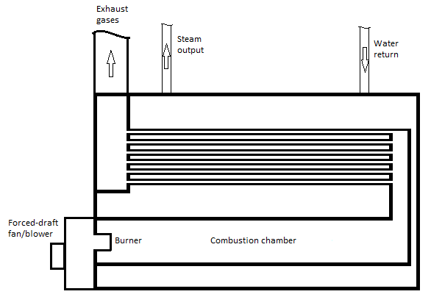A boiler is a closed vessel in which a liquid is heated and changed into a vapor. Most boilers heat water into steam by applying heat resulting from the combustion of fuel (for example, natural gas), electrical resistance, or the recovery and conversion of normally unused energy. The steam is used to heat buildings or for various processes, such as running a steam turbine, refining oil, or drying paper.

There are two basic types of boilers—watertube, a boiler in which tubes contain water and steam, with heat being applied to the outside surface; and firetube, a boiler with straight tubes, which are surrounded by water and steam and through which hot gases from combustion pass.

A boiler is almost always part of a closed loop system, whereby the boiler receives feed water that consists of varying proportions of recovered condensed water (return water) and fresh/purified water. The steam, which escapes from the boiler, consists mainly of pure water vapor.

Figure . Fire-tube boiler

In the case of a gas-burning boiler (for example, natural gas or propane), heat energy is applied to the process by burning fuel. A positive pressure line and control valve supply fuel to the boiler. A pilot flame controls the flow of fuel through the valve. . A separate control valve supplies fuel for the pilot flame. A thermocouple provides a positive indication of an established pilot flame (proving the pilot). When the pilot flame is established, the main fuel valve may be opened and the burner ignited as fuel comes in contact with the pilot.

In order to obtain combustion, air must be available to the combustion chamber. To ensure that sufficient airflow (draft) is provided to the combustion chamber, a forced-draft air fan or blower may be used. This forced-draft fan/blower is often integrated with the burner assembly.

Small boilers often cycle on and off to maintain steam pressure. When the burner starts, it goes through a purge cycle where the primary fan blows fresh air through the boiler and stack to blow out any combustible gasses that may have accumulated. When the burner shuts off, there is a similar post purge cycle. Both the pre- and the post-purge cycles cool down the inside of the boiler somewhat, but they are necessary for safety reasons.

Modern boilers may have several built-in safety devices to ensure safe operation. One example of a safety device is the pilot assembly itself. If, for any reason, fuel is not available to the pilot, the main fuel valve closes and fuel cannot flow to the burner. This ensures that an unimpeded flow of unburned fuel cannot occur. In addition to the prove pilot mechanism, a boiler may include sensors to measure fuel flow, airflow, steam temperature, steam pressure, and so on. A boiler controller may provide a "safety interlock" mechanism, which ensures the boiler is in a safe state before beginning the startup sequence.

# Section B—General Application Requirements

The application should fulfill the following requirements.

* Function as specified in *Section C: Application Requirements* of this document.
* Conform to LabVIEW coding style and documentation standards found in LabVIEW documentation. Refer to the *Development Guidelines* section of the *LabVIEW Help.*
* Be hierarchical in nature. All major functions should be performed in subVIs.
* Be easily scalable to add more states or features without having to manually update the hierarchy.
* Minimize the use of excessive structures, local or global variables, and Property Nodes.
* Respond to front panel controls within 100 ms and not use 100% of CPU time.
* Close all opened references and handles where used.
* Be well documented and include the following documentation features.
  + Labels on appropriate wires within the main VI and subVIs
  + Descriptions for each algorithm
  + Documentation in **VI Properties » Documentation** for both main VI and subVIs
  + Tip strips and descriptions for front panel controls and indicators
  + Labels for constants

# Section C—Application Requirements

## Definitions

This section defines the terminology for the project.

* Forced draft fan — Provides fresh air to the pilot flame for combustion while the boiler is running. A sensor on the boiler indicates when the forced draft fan is on.
* Fuel control valve — Controls the flow of fuel to the boiler while it is running. This control has a maximum and minimum allowed value while the boiler is running.
* Fuel level — Sensor on the boiler that indicates the flow of fuel to the boiler as a percentage of its maximum.
* Pilot decrement — Time (in milliseconds) for the pilot flame level to decrease by 1% while the boiler is shutting down.
* Pilot flame — Ignites fuel to start combustion. A sensor on the boiler indicates when the pilot light has been ignited.
* Pilot flame level — Sensor on the boiler that indicates the size of the pilot flame as a percentage of its maximum.
* Pilot gas valve — Supplies natural gas as fuel to ignite the pilot flame. A sensor on the boiler indicates when the pilot gas valve is open.
* Pilot increment — Time (in milliseconds) for the pilot flame level to increase by 1% while it is being proved.
* Primary Fan — Generates air flow during purge cycles. A sensor on the boiler that indicates when the primary fan is on.
* Proving the pilot — Process for ensuring that the pilot flame level reaches a pre-defined safety threshold before turning on the forced draft fan and starting the flow of fuel to the boiler.
* Purge cycle — A safety process for removing any combustible gasses that may have accumulated in the combustion chamber. The purge cycle typically runs before starting the boiler and during shutdown.
* Purge time — Duration (in seconds) of the purge cycle. During this time, the primary fan remains on.
* Run interlock — A safety mechanism that ensures the boiler is in a safe state before beginning the startup sequence. A sensor on the boiler indicates when the run interlock requirements have been satisfied.

## Task:

## Develop a boiler controller using LabVIEW. The front panel of the controller should look similar to the front panel shown in Figure 2.

Figure 2. Controller Front Panel

## General Operation

The boiler controller allows a user to start up and shut down a boiler. The user interacts with controls on the front panel to start up and shut down the boiler and simulate conditions in the system. Indicators on the front panel display the status and the current step in the startup and shutdown process. The controller also logs events as they occur during the process.

## Sequence of Operation

This section describes the sequence the operator follows to operate the boiler controller.

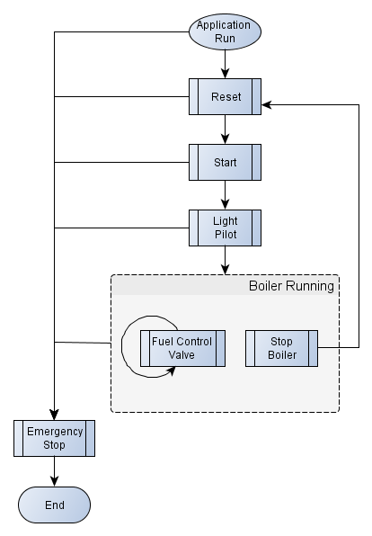

Figure 3. Boiler Controller Sequence of Operation

### Application Run

When the application starts, the **Status** string indicates **Lockout** and all indicator LEDs are OFF. Initialize controls as indicated in Table 1.

Table 1. Initial Values for the Boiler Controller User Interface

|  |  |
| --- | --- |
| Control | Initial Value |
| Fuel Control Valve | **0** |
| Fuel Control Valve Minimum | **10** |
| Fuel Control Valve Maximum | **75** |
| Status | **Lockout** |
| All Boolean LEDs | OFF |

The **Reset** and **Emergency Stop** buttons and all indicators are enabled. All other controls are disabled to ensure that the operator starts the boiler properly.

The application reads configuration data from a user-specified INI file. These values initialize the boiler controller and the boiler. You can use different INI files for different boilers.

When initialization completes, log the following data to the status log file:

* Time string: Absolute date and time at event
* Event string: **Boiler Initialized**
* Event data string: **-**  
  (There is no relevant data to log for this process)

**Note:** Refer to the *File Specifications* sectionfor file format and update policies for the status log file and the INI file.

### Reset

Click the **Reset** button to activate the run interlock on the boiler to ensure that the boiler is in a safe state before continuing through start-up.

When the run interlock completes, the **Status** string indicates **Ready** and log the following data to the status log file.

* Time string: Absolute date and time at event
* Event string: **Boiler Ready**
* Event data string: **-**   
  (There is no relevant data to log for this process)

Enable the **Start** button and disable the **Reset** button to ensure that the operator starts the boiler properly.

### Start

Click the **Start** button to execute the pre-purge process to clear combustible gasses from the combustion chamber prior to starting the boiler for safety reasons.

When this step begins, log the following data to the status log file.

* Time string: Absolute date and time at event
* Event string: **Start Pre-Purge**
* Event data string: **0**

Disable the **Start** button so that the operator does not click it a second time during the purge cycle.

During pre-purge, the **Primary Fan** turns on. This step lasts for the purge time specified in the INI file. During this time, the **Status** string indicates **Pre-Purge**.

After the pre-purge completes, the **Status** string indicates **Pre-Purge Complete** and the **Primary Fan** turns off. Log the following data to the status log file.

* Time string: Absolute date and time at event
* Event string: **Pre-Purge Complete**
* Event data string: The purge time value, as specified by the INI file.

Enable the **Light Pilot** button to ensure that the operator starts the boiler properly.

### Light Pilot

Click the **Light** **Pilot** button to ignite the pilot, prove the pilot, and start the boiler.

Disable the Light Pilot button to ensure that the operator starts the boiler properly.

#### Ignition

This step opens the pilot gas valve (turn on the **Pilot Gas Valve** LED) to start the flow of natural gas to the pilot and simultaneously creates a spark to ignite the pilot (turn on the **Pilot** LED).

When the pilot ignites, change the **Status** string to indicate **Pilot On** and log the following data to the status log file.

* Time string: Absolute date and time at event
* Event string: **Pilot ON**
* Event data string: **True**

#### Prove the Pilot

This step ensures that the pilot flame reaches an adequate level before opening the fuel control valve to start the flow of natural gas to the boiler.

When the **Pilot Flame Level** on the boileris greater than the flame threshold value read from the INI file, the **Status** string indicates **Boiler Ready**. Log the following data to the status log file.

* Time string: Absolute date and time at event
* Event string: **Pilot Proved**
* Event data string: The flame threshold value, as specified by the INI file

#### Start the Boiler

This step starts the flow of air and natural gas to the combustion chamber and turns off the pilot flame.

Start the flow of air to the combustion chamber by turning on the forced draft fan (turn on the **Forced Draft Fan** LED).

Start the flow of natural gas to the combustion chamber by opening the fuel control valve (enable the **Fuel Control Valve**). While the boiler is running, the fuel control valve should remain between the maximum/minimum values specified in the INI file.

When the boiler is running, the **Status** string indicates **Boiler Running**. Enable the **Stop Boiler** button so that the operator can safely shut down the boiler during normal operation. Log the following data to the status log file.

* Time string: Absolute date and time at event
* Event string: **Forced Draft Fan ON**
* Event data string: **True**

Now that the boiler is running, close the pilot gas valve (turn off the **Pilot Gas Valve** LED), which turns off the pilot flame (turn off the **Pilot** LED). The boiler now begins monitoring its **Simulate Failure** button.Log the following data to the status log file.

* Time string: Absolute date and time at event
* Event string: **Boiler Running**
* Event data string: Value of Fuel Control Valve Position

### Stop Boiler

Stop the flow of natural gas to the combustion chamber to stop combustion and initiate a purge cycle to clear any remaining combustible gasses from the combustion chamber.

Either of the following conditions can shut down the boiler when it is running.

* Click the **Stop Boiler** button.
* Click the **Simulate Failure** button on the Boiler.

Set the Status string to **Shutdown**. Close the fuel control valve (set the value of **Fuel Control Valve** to zero and disable it) to stop the flow of natural gas to the combustion chamber. This results in the **Pilot Flame Level** of the boiler decreasing to zero. Turn off the forced draft fan (turn off the **Forced Draft Fan** LED).

When combustion stops, initiate a purge cycle. As with the pre-purge cycle, the **Primary Fan** turns on. This step lasts for the purge time specified in the INI file. During this time, the **Status** string indicates **Purge**. Log the following data to the status log file.

* Time string: Absolute date and time at event
* Event string: **Start Shutdown Purge**
* Event data string: **0**

After the purge cycle completes, the **Status** string indicates **Lockout.** The **Primary Fan** and **Run Interlock** LEDs turn OFF.

Log the following data to the status log file.

* Time string: Absolute date and time at event
* Event string: **Shutdown Purge Complete**
* Event data string: Purge elapsed time

### Emergency Stop

This button shuts down the application completely. Click this button to halt execution of all parallel loops, close all open references, and exit.

## Handle Errors

Depending on the type of error, the system should respond differently.

* Critical errors — Result from problems that prevent the application from executing safely. These errors halt the application in the same manner as the Emergency Stop button. Log critical errors to disk.  
  **Note:** Refer to the *File Specifications* section for file format and update policies.
* Non-critical errors — Glitches or minor problems that do not affect safety and do not prevent normal execution. Handle these errors locally instead of shutting down the system.

## Description of Controls and Indicators

Table 2. Description of Controls

|  |  |  |
| --- | --- | --- |
| Control Name | Description | Function |
| **Reset** | Button | Resets the boiler |
| **Start** | Button | Initiates the pre-purge step |
| **Light Pilot** | Button | Initiates the ignition step |
| **Fuel Control Valve** | Numeric | Controls amount of fuel flowing into the boiler |
| **Stop Boiler** | Button | Initiates the boiler shutdown |
| **Emergency Stop** | Button | Stops the application within the specified time frame |

Table 3. Description of Indicators

|  |  |  |
| --- | --- | --- |
| Indicator Name | Description | Function |
| **Status** | String | Indicates boiler status (current step) |
| **Primary Fan** | LED | Indicates ON/OFF status of the primary fan |
| **Pilot Gas Valve** | LED | Indicates ON/OFF status of the natural gas valve |
| **Pilot** | LED | Indicates ON/OFF status of the pilot |
| **Forced Draft Fan** | LED | Indicates ON/OFF status of the forced draft fan |

## File Specifications

This section describes the three files the boiler controller uses to initialize configuration data, log status information, and log error information.

### INI File Specification

* **File Name**: Boiler Init.ini
* **File Location**: Relative – same location as the main VI
* **Format**: Configuration file
  + Sections — Message Handling Loop (MHL), Controller, Boiler
  + Keys:
    - MHL
      * Fuel Control Valve Maximum
      * Fuel Control Valve Minimum
    - Controller
      * Purge Time
      * Flame Threshold
    - Boiler
      * Pilot Increment (ms)
      * Pilot Decrement (ms)
* **File Creation and Modification**: Create the file and add configuration data as needed for the application.

### Status Log File Specification

* **File Name**: Status Log.txt
* **File Location**: Relative – same location as the main VI
* **Format**: Tab-delimited text file
* **File Header**: Timestamp, Event, Event Data
* **Event Data string format**:
  + Absolute date and time string
  + Event string
  + Event data string
* **File Creation and Modification**: If file does not exist, create new, write header and log status data. If file exists, append status data to the end of the file.

### Error Log File Specification

* **File Name**: Error Log.txt
* **File Location**: Relative – same location as the main VI
* **Format**: Tab-delimited text file
* **Error Data string format**:
  + Absolute date and time string
  + Error Code
  + Error Source (the full call chain information is not needed)
* **File Creation and Modification**: If file does not exist, create new and log error data. If file exists, append error data to the end of the file.